**Industrial Internship Report on**

**”Crop and Weed Detection”**

**Prepared by**

**Snigdha Singh**

|  |
| --- |
| *Executive Summary* |
| This report provides details of the Industrial Internship provided by upskill Campus and The IoT Academy in collaboration with Industrial Partner UniConverge Technologies Pvt Ltd (UCT).  This internship was focused on a project/problem statement provided by UCT. We had to finish the project including the report in 6 weeks’ time.  My project was “Crop And Weed Detection”  This internship gave me a very good opportunity to get exposure to Industrial problems and design/implement solution for that. It was an overall great experience to have this internship. |

**TABLE OF CONTENTS**

1 Preface 3

2 Introduction 4

2.1 About UniConverge Technologies Pvt Ltd 4

2.2 About upskill Campus 8

2.3 Objective 9

2.4 Reference 9

2.5 Glossary 10

3 Problem Statement- 11

4 Existing and Proposed solution 12

5 Proposed Design/ Model 13

5.1 Low Level Diagram 13

5.2 Interfaces (if applicable) 13

6 Performance Test 14

6.1 Test Plan/ Test Cases 14

6.2 Test Procedure 14

6.3 Performance Outcome 14

7 My learnings 15

8 Future work scope 16

# Preface

Summary of the whole 6 weeks’ work.

About need of relevant Internship in career development.

Brief about Your project/problem statement.

Opportunity given by USC/UCT.

How Program was planned



Your Learnings and overall experience.

Thank to all (with names), who have helped you directly or indirectly.

Your message to your juniors and peers.

# Introduction

## About UniConverge Technologies Pvt Ltd

A company established in 2013 and working in Digital Transformation domain and providing Industrial solutions with prime focus on sustainability and RoI.

For developing its products and solutions it is leveraging various**Cutting Edge Technologies e.g. Internet of Things (IoT), Cyber Security, Cloud computing (AWS, Azure), Machine Learning, Communication Technologies (4G/5G/LoRaWAN), Java Full Stack, Python, Front end**etc.



1. UCT IoT Platform **(****)**

**UCT Insight** is an IOT platform designed for quick deployment of IOT applications on the same time providing valuable “insight” for your process/business. It has been built in Java for backend and ReactJS for Front end. It has support for MySQL and various NoSql Databases.

* It enables device connectivity via industry standard IoT protocols - MQTT, CoAP, HTTP, Modbus TCP, OPC UA
* It supports both cloud and on-premises deployments.

It has features to  
• Build Your own dashboard  
• Analytics and Reporting  
• Alert and Notification  
• Integration with third party application(Power BI, SAP, ERP)  
• Rule Engine

 

1. **Smart Factory Platform (****)**

Factory watch is a platform for smart factory needs.

It provides Users/ Factory

* with a scalable solution for their Production and asset monitoring
* OEE and predictive maintenance solution scaling up to digital twin for your assets.
* to unleased the true potential of the data that their machines are generating and helps to identify the KPIs and also improve them.
* A modular architecture that allows users to choose the service that they what to start and then can scale to more complex solutions as per their demands.

Its unique SaaS model helps users to save time, cost and money.

 

1.  based Solution

UCT is one of the early adopters of LoRAWAN teschnology and providing solution in Agritech, Smart cities, Industrial Monitoring, Smart Street Light, Smart Water/ Gas/ Electricity metering solutions etc.

1. Predictive Maintenance

UCT is providing Industrial Machine health monitoring and Predictive maintenance solution leveraging Embedded system, Industrial IoT and Machine Learning Technologies by finding Remaining useful life time of various Machines used in production process.



## About upskill Campus (USC)

upskill Campus along with The IoT Academy and in association with Uniconverge technologies has facilitated the smooth execution of the complete internship process.

USC is a career development platform that delivers **personalized executive coaching** in a more affordable, scalable and measurable way.



Seeing need of upskilling in self paced manner along-with additional support services e.g. Internship, projects, interaction with Industry experts, Career growth Services

<https://www.upskillcampus.com/>

upSkill Campus aiming to upskill 1 million learners in next 5 year

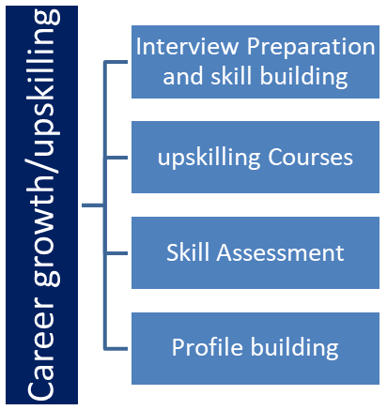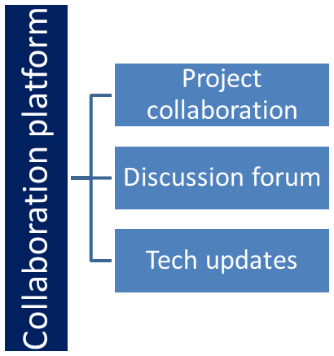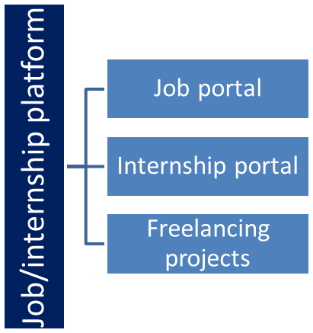

## The IoT Academy

The IoT academy is EdTech Division of UCT that is running long executive certification programs in collaboration with EICT Academy, IITK, IITR and IITG in multiple domains.

## Objectives of this Internship program

The objective for this internship program was to

 ☛ get practical experience of working in the industry.

 ☛ to solve real world problems.

 ☛ to have improved job prospects.

 ☛ to have Improved understanding of our field and its applications.

 ☛ to have Personal growth like better communication and problem solving.

## Reference

[1] https://github.com/ravirajsinh45/Crop_and_weed_detection

[2] https://www.bing.com/ck/a?!&&p=6b72cbd0f137328aJmltdHM9MTY5MTAyMDgwMCZpZ3VpZD0wM2M4YmU3Yy03MTczLTZiNGUtM2RlMi1hZDRiNzBlODZhYmYmaW5zaWQ9NTIxMg&ptn=3&hsh=3&fclid=03c8be7c-7173-6b4e-3de2-ad4b70e86abf&psq=+crip+and+weed+detection&u=a1aHR0cHM6Ly93d3cua2FnZ2xlLmNvbS9kYXRhc2V0cy9yYXZpcmFqc2luaDQ1L2Nyb3AtYW5kLXdlZWQtZGV0ZWN0aW9uLWRhdGEtd2l0aC1ib3VuZGluZy1ib3hlcw&ntb=1

[3] researchgate.net

[4] paperswithcode.com

## Glossary

|  |  |
| --- | --- |
| Terms | Acronym |
| UCT | Uniconverge Technologies |
| CNN | Convolutional Neural Networks |
| ANN | Artificial neural Networks |
| VGG19 | CNN model |
|  |  |

# Problem Statement

In order to meet the demand for food products due to the growing population we need greater productive capability in agricultural sectors.Green revolution caused a rapid acceleration in this field terms of profit from the cash crops.The increased use of pesticides and herbicides had a huge impact and as a side effect it cause a huge damage to the environment.So in this project,we have implemented methods to reduce the usage of these herbicides by spraying them only in the areas where weeds are present.We have implemented image processing using MaskRCNN to detect weed area in an image.

To get rid of following problems in agriculture:--

a. how to detect weed among all the crops?

b.how to increase productivity extensively?

c.how to monitor the sprinkling of pesticides over crops only and not on weeeds?

d.how to make technology implementable in agriculture?

e.how to handle all the arising issues , unlike traditional methods?

# Existing and Proposed solution

**Summary of existing solutions –**

there were several existing solutions for crop and weed detection, many of which utilized various technologies and approaches. Please keep in mind that there might have been further advancements beyond my knowledge cutoff date, so it's a good idea to conduct more recent research for the latest developments. Here is a summary of some common approaches:

1. **Remote Sensing and Satellite Imagery**: Satellites equipped with sensors capture images of agricultural fields, and these images are then analyzed using image processing and machine learning algorithms to identify crops and detect weeds. This approach provides a large-scale view of agricultural areas and can help in monitoring crop health and weed infestations.
2. **Unmanned Aerial Vehicles (UAVs) or Drones**: Drones equipped with high-resolution cameras or other sensors fly over fields, capturing detailed images. These images are then analyzed using computer vision and machine learning techniques to identify crops, assess their health, and detect weeds. Drones offer more detailed information compared to satellite imagery and are particularly useful for smaller farms.
3. **Ground-Based Imaging**: On-the-ground imaging using smartphones or specialized cameras can also be used to capture images of crops and weeds. Computer vision algorithms are then applied to these images for detection and analysis.
4. **Machine Learning and Deep Learning**: Various machine learning and deep learning algorithms are applied to analyze the collected images and identify patterns associated with crops and weeds. Convolutional Neural Networks (CNNs) have been particularly successful in image recognition tasks.

These solutions aim to improve crop management, increase yields, and reduce the environmental impact of agriculture by efficiently identifying and managing weed infestations. As technology continues to advance

**Proposed solution?**

1. **Advanced Machine Learning and Deep Learning Models**: Researchers were continuously working on improving the performance of crop and weed detection algorithms using more advanced machine learning and deep learning models. For instance, there was a growing interest in employing transformer-based architectures like BERT and Vision Transformers (ViTs) to achieve better results in image recognition tasks.
2. **Multi-Sensor Fusion**: The integration of data from multiple sensors, such as combining visual data with LiDAR or hyperspectral data, was gaining traction. This multi-sensor fusion could provide a more comprehensive understanding of the crop and weed distribution in agricultural fields.
3. **Edge Computing and Real-Time Analysis**: Efforts were being made to develop on-device or edge computing solutions to enable real-time crop and weed detection. This would allow farmers to receive instant feedback and take immediate actions based on the analysis results.
4. **Transfer Learning and Domain Adaptation**: Transfer learning techniques were being explored to make crop and weed detection models more adaptable to different geographic regions and varying environmental conditions. Domain adaptation methods aimed to reduce the need for retraining models for every specific location.
5. **Robotic and Autonomous Systems**: Robotics and autonomous systems for weed control were receiving more attention. These systems could autonomously navigate through fields, identify and remove weeds, reducing the reliance on herbicides and manual labor.

Top of Form

**What value addition are you planning?**

In a crop and weed detection project, several value additions can be planned to enhance the overall effectiveness and usefulness of the solution. Here are some potential value additions to consider:

1. **Multi-Class Detection**: Extend the model to detect not only crops and weeds but also other objects or elements relevant to agriculture, such as pests, diseases, or specific crop varieties. This would provide a more comprehensive understanding of the field's condition and enable farmers to address multiple challenges simultaneously.
2. **Crop Health Assessment**: Integrate algorithms to assess the health of crops based on visual cues and spectral data. This would help farmers identify early signs of stress, nutrient deficiencies, or diseases, enabling timely intervention and better crop management.
3. **Yield Estimation**: Include features that allow the system to estimate crop yields based on the detected crops. Accurate yield estimation helps in better planning and decision-making for harvesting and post-harvest operations.
4. **Weed Classification**: Rather than just detecting weeds, improve the system to classify and differentiate between different weed species. Different weeds may require different management strategies, so this information can help farmers select the most suitable approach.
5. **Mobile Application**: Develop a user-friendly mobile application that enables farmers to capture images of their fields and receive real-time analysis and recommendations. An intuitive app can encourage wider adoption of the technology.
6. **Integration with Precision Agriculture Tools**: Integrate the crop and weed detection system with existing precision agriculture tools, such as

Top of Form

Regenerate

## Code submission (Github link)

https://github.com/SnigdhaSingh01/weed_detection

## Report submission (Github link) : report attached to same github link

https://github.com/SnigdhaSingh01/weed_detection

4.3

# Proposed Design/ Model

The specifics of a machine learning (ML) model for crop and weed detection can vary based on the data, technology, and approach used in a particular project. However, I can provide an overview of a typical pipeline and the components involved in such a model:

1. **Data Collection**: The first step is to gather data, which may include images or sensor data from sources like satellites, drones, or ground-based cameras. The data should cover a wide range of crop and weed types, growth stages, and environmental conditions to ensure the model's generalization capability.
2. **Data Preprocessing**: Raw data is often noisy and requires preprocessing to make it suitable for model training. Preprocessing steps may involve resizing images, normalizing pixel values, removing artifacts, and applying data augmentation techniques to increase the size of the dataset and improve model robustness.
3. **Feature Extraction**: For image-based models, feature extraction is a critical step. Convolutional Neural Networks (CNNs) are commonly used for this purpose. CNNs can automatically learn hierarchical representations of the input images, identifying essential patterns and features relevant for classification.
4. **Labeling and Annotation**: The dataset needs to be labeled, indicating which parts of the images correspond to crops and weeds. This is typically done through manual annotation or using semi-automatic tools.
5. **Model Architecture**: Once the data is ready, the model architecture is designed. A common choice is to use pre-trained CNNs (e.g., VGG, ResNet, or Inception) as feature extractors and then add additional layers for classification. Transfer learning, where a model trained on a

Top of Form

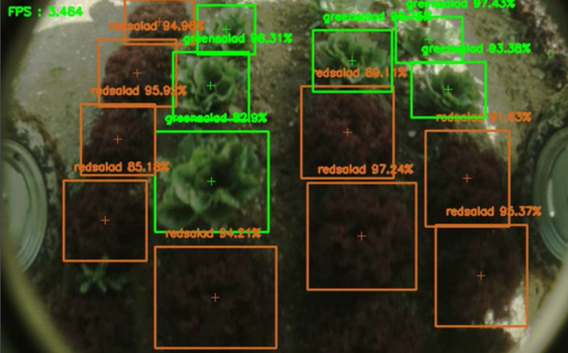

Figure 1: HIGH LEVEL DIAGRAM OF THE SYSTEM

## Low Level Diagram

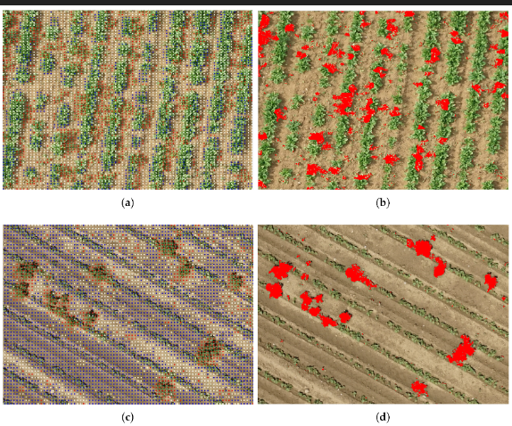

## Interfaces

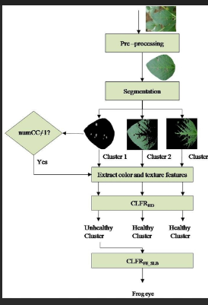

Block diagram of crop and weed detection algo

# Performance Test

Performance tests in a crop and weed detection project aim to assess the effectiveness and accuracy of the developed model or system. These tests are crucial to understanding how well the solution performs under different conditions and to identify areas for improvement. Here are some common performance tests for crop and weed detection projects:

1. **Accuracy and Error Metrics**: Calculate accuracy, precision, recall, F1-score, and confusion matrix to evaluate the model's overall performance in correctly identifying crops and weeds. These metrics provide insights into true positives, false positives, true negatives, and false negatives, helping to understand where the model excels and where it struggles.
2. **Sensitivity to Weed Density**: Test the model's performance at different weed densities. Weed detection might be more challenging when the weed density is high, and the model's accuracy could be affected. Understanding this sensitivity is essential to assess the system's real-world applicability.

## Test Plan/ Test Cases

Test cases in crop and weed detection are specific scenarios or inputs designed to verify and validate the accuracy and functionality of the model or system. Here are some example test cases for crop and weed detection:

1. **Positive Crop Detection**: Test the model with images containing different types of crops at various growth stages. Ensure that the model accurately identifies and classifies the crops present in the image.
2. **Positive Weed Detection**: Test the model with images containing different weed species at different densities. Verify that the model correctly detects and labels the weeds in the image.
3. **Negative Detection**: Test the model with images of landscapes without any crops or weeds. The model should correctly recognize that no crops or weeds are present in the image.
4. **Mixed Crop and Weed Detection**: Test the model with images containing a mixture of crops and weeds. Ensure that the model can distinguish between crops and weeds accurately.

## Test Procedure

The test procedure in crop and weed detection involves a series of steps to evaluate the performance and effectiveness of the developed model or system. Here's a general test procedure for crop and weed detection projects:

1. **Data Splitting**: Divide the labeled dataset into three subsets: training set, validation set, and test set. The training set is used to train the model, the validation set is used for hyperparameter tuning and model selection, and the test set is kept separate for final evaluation.
2. **Training**: Train the crop and weed detection model using the training set. The model's architecture and hyperparameters should be selected based on the performance on the validation set.
3. **Validation**: Evaluate the model's performance on the validation set. Monitor key metrics like accuracy, precision, recall, F1-score, and confusion matrix. Adjust model parameters and architecture as needed to improve performance.

## Performance Outcome

The outcome of a crop and weed detection model is the ability to accurately identify and distinguish between crops and weeds in images or sensor data. The model's primary objective is to provide a binary classification for each pixel or region in the input data, labeling it as either a crop or a weed. The model's predictions can be visualized as a heatmap or an overlay on the original image, highlighting the areas where crops and weeds are detected.

Specifically, the model's outcome can be summarized as follows:

1. **Crop Detection**: The model accurately identifies and labels regions in the image that correspond to crops. These regions may include individual plants or entire fields of crops.
2. **Weed Detection**: The model successfully detects and labels regions in the image that correspond to weeds. These regions may include individual weed plants or weed-infested areas in the field.
3. **Classification Confidence**: For each detection, the model provides a confidence score or probability, indicating how confident it is about its classification (i.e., crop or weed). This confidence score helps in understanding the reliability of the model's predictions.
4. **Visualization**: The model's predictions can be visualized using color-coded overlays

Top of Form

# My learnings

he crop and weed detection model is an advanced machine learning system designed to identify and distinguish between crops and weeds in agricultural images or sensor data. This model leverages techniques from computer vision and deep learning to achieve accurate and real-time detection results. Its main features and capabilities can be summarized as follows:

1. **Objective**: The primary objective of the model is to accurately classify pixels or regions in the input data as either crops or weeds, providing a binary classification for each location.
2. **Data Source**: The model can utilize various data sources, including satellite imagery, aerial imagery from drones, ground-based cameras, or other sensors, to analyze the agricultural fields.
3. **Image Processing**: Before analysis, the raw data undergoes preprocessing, which includes resizing, normalization, and data augmentation to prepare it for model training.
4. **Feature Extraction**: The model employs Convolutional Neural Networks (CNNs) as feature extractors to automatically learn

# Future work scope

The future scope of crop and weed detection models is promising, with several exciting developments and opportunities on the horizon. As technology advances and new research emerges, the following areas hold great potential for further improvement and innovation in crop and weed detection:

1. **Multi-Sensor Fusion**: Integrating data from multiple sensors, such as combining visual data with LiDAR, hyperspectral, or thermal data, can provide more comprehensive and accurate information about crops and weeds. Multi-sensor fusion can enhance detection capabilities and lead to better insights for farmers.
2. **Advanced Deep Learning Architectures**: Continued advancements in deep learning architectures, such as transformers and other self-attention mechanisms, can further improve feature extraction and modeling capabilities, leading to more accurate and robust crop and weed detection models.
3. **Continual Learning and Adaptation**: Developing models that can continuously learn and adapt from new data without forgetting previously acquired knowledge is essential for long-term performance improvement and handling changing agricultural conditions.